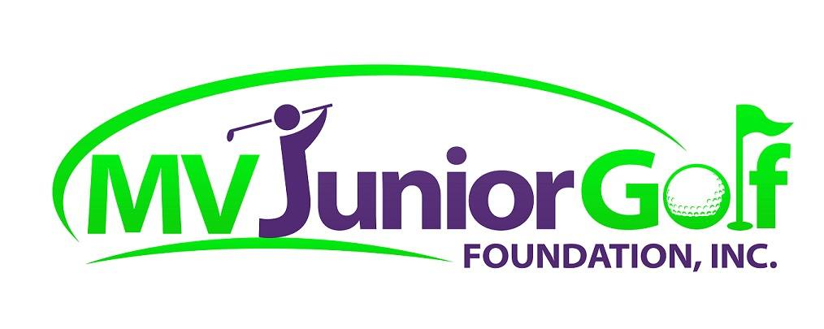
2017 SCHOLARSHIP APPLICATION
MV Junior Golf Foundation, Inc. is a 501(c)(3) nonprofit corporation organized to provide junior boys and girls in the Magic Valley and surrounding areas with the opportunity to play golf, in competitive and noncompetitive environments, while learning life skills of respect, sportsmanship, perseverance, etiquette and honesty. It is the focus of the Foundation to provide ALL juniors, regardless of economic, physical and developmental challenges, with the opportunity to participate in a junior golf program.
The Foundation is awarding scholarships to 2017 high school graduates in the Magic Valley, Mini Cassia and immediate surrounding areas pursuing a post-graduate education or vocational training. Scholarships will be remitted directly to the educational or vocational institutions of the recipients. This scholarship is intended for individuals who have developed a significant passion for the game of golf whether it be in a highly competitive or noncompetitive environment. In addition to this application, applicants must submit two letters of recommendation and a copy of his/her high school transcript. Applications are due on or before July 31, 2017. Scholarship recipients will be selected on or before August 15, 2017.

1. Applicant Information
1.1 Name of Applicant:
1.2 Residence Address:
City: Zip Code:
1.3 Mailing Address:
City: Zip Code:
1.4 Telephone:_______-_______-_______ Email:
1.5 Date of Birth:
1.6 High School Graduated From:
1.7 Date of Graduation: Cumulative GPA: Class Rank:
1.8 Extracurricular and Volunteer Activities Involved In:

2. College, University or Trade School Information
2.1 College, University or Trade School attending, Fall of 2017:

2.2 Please list Scholarships and Financial Aid you will be receiving:
$
$
$
2.3 Educational Goals:

2.4 Career Goals:

3. Leadership Activities: List extracurricular high school activities and community programs below, including all awards and leadership positions held.
3.1 High School:

3.2 Community Service Programs:

3.3 Scholastic Honors:

4. Golf Background: High School and competitive golf experience–include titles, awards and championships. Programs participated in promoting golf as a lifetime sport and volunteer service to golf related programs.

5. On a separate sheet, please respond to the following question in 300 words or less.
What is the most difficult situation you have encountered during a golf competition or golf related activity, and ultimately how will that experience benefit you off of the golf course?
6. REQUIRED INFORMATION:
6.1 Copy of latest transcript from the High School just graduated from.
6.2 Two letters of recommendation. Letters from instructors, principals, golf professionals or individuals in your community who know you are suitable. People providing reference letters must include name, address telephone number, affiliation with you and the length of time they have known you, together with the reasons they believe you are a worthy recipient of a scholarship.
6.3 Complete, signed Application submitted to MV Junior Golf Foundation, Inc., PO Box 5455, Twin Falls, ID 83303-5455. APPLICATION AND ALL REQUIRED INFORMATION MUST BE RECEIVED ON OR BEFORE JULY 31, 2017.
7. DECLARATION OF APPLICANT.
I understand the foregoing terms and conditions and hereby make application for a MV Junior Golf Foundation, Inc. Scholarship. I certify that the information given in this application is true and complete. MV Junior Golf Foundation, Inc. is hereby authorized to verify information contained herein with those concerned and the educational institutions and other sources identified in this application and I agree to notify the MV Junior Golf Foundation, Inc. of any changes to the information contained in this application. If I receive a scholarship, I agree to allow my name, photograph, study plans, golf and other accomplishments to appear publicly as deemed appropriate by the Foundation.

Signature of Applicant Date

Please submit all applicant material to:
MV Junior Golf Foundation, Inc.
PO Box 5455
Twin Falls, ID 83303-5455

Applications must be received on or before July 31, 2017

